



**SMBE Regional Symposium on Evolutionary Genomics in Agriculture, Environment, Biodiversity conservation and Health for Africa, 2026**

**Preamble**

The University of Eldoret, Kenya, under the auspices and support of the Society for Molecular Biology and Evolution (SMBE) will host the SMBE Regional Symposium on Evolutionary Genomics in Agriculture, Environment, Biodiversity conservation and Health, in Eldoret. Evolutionary genomics is important in addressing critical questions and providing tools and strategies in agricultural production, natural resource management and biodiversity conservation, because of their power, accuracy and applicability, supported by advanced analytical and computational platforms. Anthropogenic activities have impacted natural ecosystems, leading to environmental disturbances, habitat fragmentation and destruction, overexploitation of natural resources, emergence of pathogens and pests, increasing disease incidences and burden. These challenges are exacerbated by climate change, severely reducing agricultural productivity, environmental health and ecosystem services. This meeting will bring together both African and international scientists to discuss Genomics approaches and tools in understanding evolutionary patterns and trends, and application of these tools for sustainable exploitation of resources, agricultural productivity, and improved environmental and human health.

**Themes of the Symposium**

Main theme: ***The role of evolutionary genomics in addressing challenges in agriculture and environment in Africa.***

Sub themes:

1. Genomics and biodiversity conservation
2. Genomics in crop improvement and production
3. Genomics in animal breeding
4. Evolutionary genomics in fisheries: Rapid diversification of cichlids of the Great Lakes of Africa
5. Genomics and evolution of antimicrobial resistance in agriculture, medicine and environment
6. Genomics in diagnosis, surveillance and management of diseases and epidemics
7. The African Biogenome Project

**Planning Institutions**

University of Eldoret, Kenya

Moi University, Kenya

University of Antwerp, Belgium

**Key Dates**

1. Dates of the Symposium: 18th May, 2026 to 20th May, 2026
2. Deadline for submitting Abstracts: 10 March, 2026
3. Deadline for Symposium registration: 30 March, 2026

**Symposium Registration Fee**

1. International Scientist - US$ 100
2. African Scientist - US$ 50
3. Student - Nil

**Details on Registration for the Symposium**

Registration will involve filling the registration form, and payment of registration fee. Both copies of Registration form and Bank deposit slips should be emailed to: [jbarasa@uoeld.ac.ke](mailto:jbarasa@uoeld.ac.ke)

Post graduate students submitting abstracts will register and attend without paying registration fee, but will need to show evidence of studentship for attendance.

**Venue of the Symposium**

The Noble Hotel and Conference Centre, Eldoret, Kenya. ([www.thenoble.co.ke](http://www.thenoble.co.ke))

**Symposium Planning Committee**

1. James Barasa Echessa - *Department of Fisheries and Aquatic Sciences, University of Eldoret, Chairperson*
2. Lizzy Aluoch Mwamburi - *Director of Research and Innovation, University of Eldoret, Member*
3. Samuel Kariuki - *Department of Biological Sciences, University of Eldoret, Member*
4. Vivian Tuei - *Department of Biochemistry and Clinical Chemistry, College of Health Sciences, Moi University, Member*
5. Wilson Sawasawa - *Department of Biology, University of Antwerp, Belgium, Member*
6. Kennedy Pkania - *De**partment of Biotechnology, University of Eldoret, Member*
7. Emily Chemoiwa - *Department of Biological Sciences, University of Eldoret, Secretariat*
8. Benson Nyongesa - *Department of Biological Sciences, University of Eldoret, Member*

**Contact details**

**Send inquiries and abstracts to:** [jbarasa@uoeld.ac.ke](mailto:jbarasa@uoeld.ac.ke)

**Abstracts**

The abstract should not exceed 300 words. Include names of author and co-authors, but underline the name of the presenter. Also indicate the sub theme under which it should be considered.

**Bank Details**

**Name:** Standard Chartered Bank

**Account Name:** University of Eldoret

**Branch:** Eldoret

**Account Number:** 0102816968200

**Swift Code**: SCBLKENX

**Additional information**

**Bursaries**

Support with modest bursaries will be available for students and early career scientists, to enable a wider participation among these groups and some countries. However, those in need should indicate so, on submission of abstracts.

**Hotel accommodation**

Delegates participating in the symposium will need to book and cover their hotel room accommodation. Eldoret has many Hotels and details of these will be provided in due course.

**Travel**

Delegates will be responsible for own travel costs and arrangements in to and out of Kenya. Reliable and safe air travel and connectivity exists between Nairobi and Eldoret. Delegates may also choose to travel by road from Nairobi to Eldoret. However, airport transfer from and to Eldoret International airport will be provided to delegates.

**Details of Guest Speakers**

1. 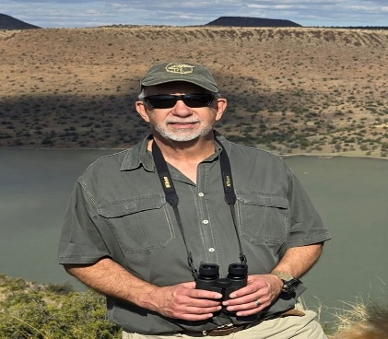**Genomics in Biodiversity conservation**

**Prof. Paul Grobler** is the Head of the Department of Genetics at the University of the Free State (UFS), South Africa, where he also leads the Population and Conservation Genetics research group. Previously, he worked at the University of Limpopo and he was Adjunct Professor in the Department of Fish and Wildlife Conservation at Virginia Tech University in the USA. With his students and collaborators, he has authored or co-authored 114 papers in accredited scientific journals. His research is focussed on a range of topics in conservation genetics. This includes genetic diversity within species, with a strong emphasis on antelope and rhino; individual-based analyses involving paternity; patterns of genetic connectivity between populations, spanning species from mussels to vervet monkeys; and the molecular identification of hybrids between the two South African species of wildebeest. Recently, his group has begun using non-invasive dung samples to conduct censuses and characterize kudu populations, while also exploring similar research on small mammals. In the field of wildlife forensics, his focus is on studying the efficiency of species determination from evidence items over time. Until recently, traditional molecular techniques were the primary tools used to study these processes. However, the rapid advancement of genomics presents new opportunities by greatly expanding the range of available markers and computational approaches. As a result, the use of genomic techniques is advancing swiftly across many areas and large volumes of genomic data is being generated, published and applied in health and agriculture. Despite this progress, the implementation of these techniques in addressing on-the-ground wildlife conservation challenges in Africa has advanced much more slowly, as is evident from interaction with conservation practitioners. In this presentation, Prof. Grobler will provide an overview of current conservation issues, explore how genomic approaches can advance conservation by deepening our understanding of population genetic processes, and investigate pathways for their practical application in the field.

**P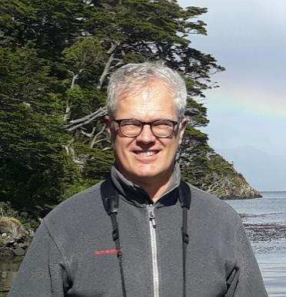rof. Dr. Ralph Tiedemann** studied at the Universities of Kiel and Iceland (Reykjavík) and obtained a PhD in Zoology in 1994. He was subsequently assistant professor at the University of Kiel and became full professor and chair for Evolutionary Biology/Systematic Zoology at the University of Potsdam, Germany, in 2002. He was guest researcher at the Free University of Brussels (ULB), Belgium and the University of Oklahoma at Norman, USA. His research focusses on speciation and adaptation in animals with different life histories. Key approaches are population genetics, evolutionary genomics, transcriptomics, and population modelling. His model systems encompass vertebrates (mammals, birds, amphibians, fish) and limnic plankton (rotifers).

The topic of his talk is Evolution of Electric Organ Discharge (EOD) in African weakly electric fishes: Genomics and behavioural ecology of a magic trait. The mormyrids comprise a species-rich group of African weakly-electric fish which has undergone an enormous radiation. This is particularly true for the genus *Campylomormyrus*,which consists of about 15 closely related species mostly restricted to the Congo basin. In combined molecular, electrophysiological, and behavioural studies, we demonstrate that (1) cryptic species are hidden behind morphometrically similar (but electro-physiologically divergent) morphotypes, (2) divergence in Electric Organ Discharge (EOD) is associated with small, but significant morphometric changes regarding the feeding apparatus, and (3) EOD is the trigger of mate recognition. The talk will give insights and patterns on proximate (genomic, transcriptomic, and histological underpinning) and ultimate (adaptive function for orientation, feeding, and mate choice) determinants of EOD evolution and divergence. The idea that the EOD as a "magic trait", i.e., a variable heritable trait which allows for both ecological diversification and species/mate recognition will be discussed.

1. **Genomics in Crop improvement and production**

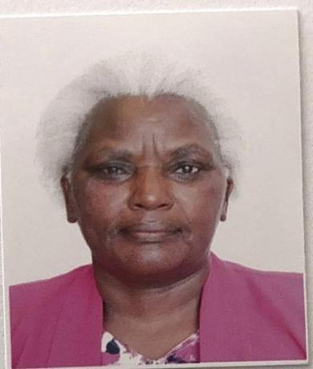**Professor Miriam Kinyua** is actively involved in teaching, extension, and research in agriculture, crop improvement and biotechnology, at the Dept of Biotechnology, University of Eldoret, Kenya. She holds a PhD in Plant breeding, MSc Plant Breeding and Genetics and BSc Agriculture, all from the University of Nairobi, Kenya. Prof Kinyua has worn over 20 projects in research funding, and has been given the Presidential award of Order of Grand Warrior (OGW) for her excellent contribution to Agricultural production through research, as well as an award for women in mutation breeding by joint FAO/IAEA for excellent work on mutation contributing to food security. She has undertaken several scientific consultancies and led expert missions to several countries in Africa, Asia, and the Americas, including a 6-month consultancy mission at the International atomic energy agency (IAEA) in Vienna, Austria, in the agriculture division and as acting head at Seibersdorf labs for 2 months. She holds over 15 patents including the latest on released mutant wheat varieties Eldo-Mavuno and Eldo-Baraka, 3 mutant potato varieties Eldo-Amani, Eldo-Bidii and Eldo-Fanaka, 3 mutant cassava lines approved for release and 4 dolichos varieties: Eldo KT black, Eldo KT Cream and Eldo KT Maridadi.

Plant breeding has been at the centre of meeting demand for food in Africa. Genomics is currently fundamental in complementing traditional breeding approaches to refine the objectives of addressing climate change and its consequential impacts in exacerbating pests and diseases, and food insecurity. Genomics has been both complementary and transformative in leveraging tools to improve resilience to abiotic and biotic stressors in crop production, thereby increasing yields and nutrient enrichment in crops tailored to African agricultural landscapes. Besides genomics, integration of genomics and mutagenesis (mutagenomics) and other multi-omics approaches are becoming key drivers to achieving tailor-made solutions to the plethora of constraints in African agroecosystems. Through active farmer engagements, i.e., participatory breeding programmes, Open-Source Genomics initiatives, and the use of AI-driven genomics approaches, gene editing and speed breeding, Africa will bridge the pertinent challenges of funding and infrastructural capacities to achieve sustainable food security and economic growth. Under Genomics as a complementary wheel in accelerating crop improvement and production in Africa, the application of these genomics tools in plant breeding, crop improvement and production in the African context will be discussed.

1. A person in a suit jacket

   Description automatically generated**Genomics in Animal breeding**

**Dr Raphael Mrode** holds a joint position as Professor of Quantitative Genetics and Genomics at the Scotland Rural College (SRUC), United Kingdom, and Principal Scientist in Quantitative Dairy Cattle genetics at the International Livestock Research Institute (ILRI), Kenya. He obtained his PhD from the University of Edinburgh on Animal Genetics and Breeding as a Commonwealth Scholar. He has been involved in the development and research underpinning genetic and genomic evaluations in dairy and beef cattle, goats and sheep in the UK for over 30 years and in the development of innovative genomic approaches to livestock genetic improvement in low-input environments at ILRI. He has been a member of technical committee of INTERBULL, the organization in charge of international dairy cattle evaluations since 2004, an auditor for the International Committee for Animal Recording (ICAR) and research consultant supporting the FAO/IAEA coordinated research project on the Application of Nuclear and Genomic Tools. He is the author of the text, ‘Linear models for the Prediction of Breeding Values, now in its fourth edition, co-author of 2 other textbooks, author of 2 book chapters, have over 100 peer-reviewed papers and more than 300 conference papers. He has been a member of the Editorial Board, American Journal of Animal Science and he is the Assistant Section Editor on Animal genetics for the journal, Animal.

In his talk, *“Genomics- the pathway for efficient breeding programmes in dairy systems in Lower-Medium Income Countries”,* he will outline the fundamentals of efficient breeding programmes for dairy cattle and the critical role of genomic approaches with applications in Sub-Saharan Africa and India.

1. **Evolutionary Genomics and Fisheries: Rapid diversification of species in Great Lakes of Africa.**

**Prof. Hannes 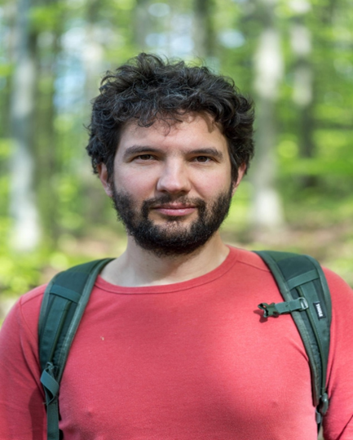Svardal.** With his non-standard career path from physics via theoretical evolution to evolutionary genomics, **Hannes** is in a good position to achieve his research goal: to uncover the fundamental forces behind the astonishing natural diversity we see on earth, how it came into being and how it is changing today. His postdocs at the Gregor Mendel Institute (Vienna), the Wellcome Sanger Institute (Cambridge), and the University of Cambridge, have led to publications in Nature Genetics, Nature Ecology and Evolution, Cell, etc. on the evolutionary genomics of a wide range of organisms. Hannes is now Associate Professor for Evolutionary, Ecological and Environmental Omics at the University of Antwerp, Belgium. His group is developing novel computational genomic approaches and applying them to a variety of study systems, with a main focus on the adaptive radiations of African cichlid fishes.

He will talk on Insights into the evolution of biodiversity from the genomes of African cichlid fishes. Cichlid fishes are one of the most species rich family of vertebrates, having formed striking adaptive radiations of 100s of species in the East African Great lakes Victoria, Tanganyika and Malawi. After a general introduction about cichlid fishes and adaptive radiations, he will present insights into the mechanisms behind adaptive radiations based on genome sequencing data of 1000s of cichlids from Lakes Malawi and the Lake Victoria region. Finally, he will discuss the role of adaptive radiations as model system to study the evolution of biodiversity, and the importance to sustainably manage and conserve African fish diversity for future generations.

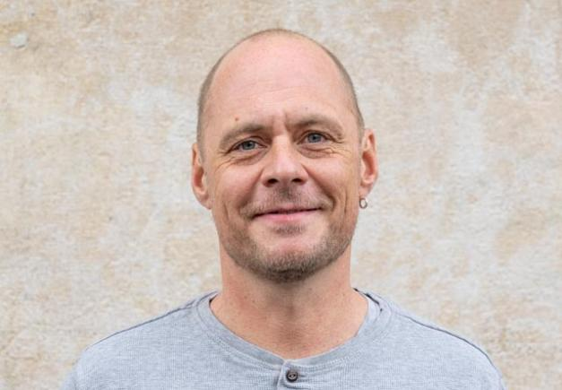

**Prof. Dr. Walter Salzburger** is an Austrian-Swiss zoologist and evolutionary biologist. He studied at the University of Innsbruck in Austria, where he received his doctoral degree in 2001. After his postdoctoral training at the University of Konstanz in Germany, he became a junior group leader at the University of Lausanne in Switzerland in 2006. In 2007, he took up the position as tenure-track assistant professor at the Zoological Institute of the University of Basel, where he was later promoted to associate and then to full professor. His research focuses on the question of how variation at the level of the DNA translates into phenotypic and ecological diversity and on the identification of the patterns and processes that underlie adaptation, evolutionary innovation, and rapid diversification. His main organismal study systems are the exceptionally diverse cichlid fishes in the African Great Lakes, particularly the cichlids of Lake Tanganyika, as well as other fish and non-fish taxa to answer questions related to the origin of biological diversity. Recent examples include work on understanding vision in deep-sea fishes and molecular adaptations to cope with subzero water temperatures in Antarctic notothenioid fishes. Walter has been awarded the Walther Arndt Prize of the German Zoological Society (in 2011) and the Johann Gregor Mendel Medal (in 2023). He also received a Starting Grant (in 2008) and a Consolidator Grant (in 2013) from the European Research Council (ERC) for his integrative work on cichlid fishes from Lake Tanganyika.

His talk is entitled: The non-gradual nature of adaptive radiation in cichlid fishes of Lake Tanganyika. Adaptive radiation is the likely source of much of the ecological and morphological diversity of life on Earth. Owing to their spectacular taxonomic, phenotypic, ecological and behavioral diversity and propensity for explosive speciation, the assemblages of cichlid fishes in the African Great Lakes Victoria, Malawi and Tanganyika are prime role models for this evolutionary process. The cichlid fishes of Lake Tanganyika constitute the morphologically, ecologically and behaviorally most diverse cichlid species flocks. Our in-depth examination of nearly all its approximately 250 cichlid species revealed that this spectacular adaptive radiation proceeded in a non-gradual manner, in the form of three consecutive and trait-specific pulses of accelerated phenotypic evolution. Three trait complexes – body shape, mouth morphology, and the lower pharyngeal jaw bone – are highly diverse and show a particularly strong association with the environment. In addition, there is evidence that diversification with respect to behavior contributed to the cichlid adaptive radiation in Lake Tanganyika.

1. **The African BioGenome Project**

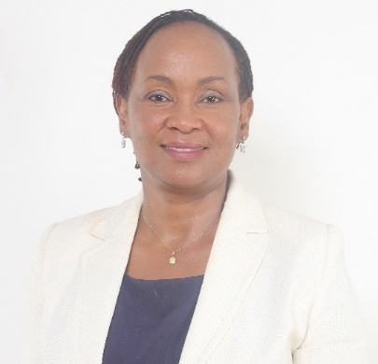**Prof. Anne Muigai** (BSc, MSc and PhD) is a molecular population geneticist with over 20 years of experience in research, academic and administrative management in the Kenyan public university sector. Before joining the National Defence University of Kenya (NDU-K) as the Deputy Vice-Chancellor, Academic Affairs and Research, she held several academic and administrative positions within Jomo Kenyatta University of Agriculture and Technology (JKUAT), Kenya, including founding Chairperson of the Department of Botany, Director of the Institute for Biotechnology Research, senate representative to the JKUAT Council, Editor in Chief of the Journal of Agriculture Science and Technology and Coordinator of the postgraduate programmes in the Department of Botany. She has served on the Boards of two State Corporations in the Republic of Kenya namely, The Commission for University Education, (2017-2022), Kenya Plant Health and Inspection Services (2015-2018). She has also served on World Health Organization (WHO) Advisory Committee to Develop Global Standards for Governance and Oversight of Human Genome Editing. Currently she serves on the Bayer Bioethics Advisory Board and is the Chairperson African BioGenome project, which seeks to characterize African plants and animals (2021-present).

Her talk is entitled: The African BioGenome Project: Harnessing Genomics and Bioinformatics to Safeguard Africa’s Biodiversity. Africa is home to an extraordinary diversity of biological organisms, spanning unique ecological landscapes such as mountain peaks, savannahs, wetlands, and forests. However, biodiversity loss is accelerating due to climate change and human-driven environmental degradation. In response to this challenge, the African BioGenome Project (AfricaBP) was launched in 2021 as a collaborative Pan-African initiative aimed at sequencing the genomes of 105,000 endemic species. By generating high-quality genomic data, AfricaBP seeks to enhance conservation efforts, improve sustainable resource management, and drive scientific innovation across the continent. This presentation will explore the progress, challenges, and transformative potential of AfricaBP in safeguarding Africa’s rich biodiversity while fostering global genomic equity.

1. **Genomics in the evolution of antimicrobial resistance (AMR) in agriculture, environment and food production systems**

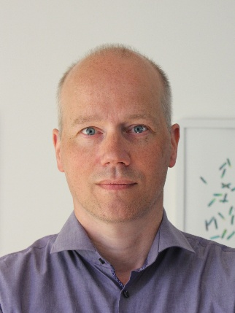**Prof Willem van Schaik**, Director and Head of Research of the School of Infection, Inflammation and Immunology of the University of Birmingham, the UK.

Prof Willem van Schaik is an expert in the biology of antibiotic-resistant opportunistic pathogens. He is Chair of Microbiology and Infection, and Head of Research of the School of Infection, Inflammation and Immunology of the University of Birmingham. Previously he was group leader at the University Medical Centre Utrecht (UMCU), The Netherlands (2010 – 2017), after completing post-doctoral research at UMCU and the Institut Pasteur (Paris, France). He gained his PhD in 2005 at Wageningen University (The Netherlands).

Prof Van Schaik’s group combines experimental tools in molecular biology and biochemistry with the opportunities offered by the development of novel, high-throughput DNA sequencing technologies and bioinformatics to elucidate the mechanisms by which harmless commensals transition into successful multi-drug resistant opportunistic pathogens. In addition, he studies the role of complex microbial ecosystems, in particular the human gut microbiome, as reservoirs of antibiotic resistance genes and is pioneering novel, sequence-based methodologies to study the transfer of mobile genetic elements carrying antibiotic resistance genes between bacteria.

He will speak on: The evolutionary transition from commensal to opportunistic pathogen. Antimicrobial resistance is a major threat to public health and modern health care, and genomics can elucidate the pathways by which commensal bacteria can evolve to become multidrug-resistant opportunistic pathogens. Here, I will provide an overview of recent work that highlights the complex evolutionary trajectories of the Gram-positive bacterium *Enterococcus faecium*, which is ubiquitously present in the gut of humans and animals, and has emerged as a major, multidrug-resistant opportunistic pathogen since the start of the 21st century. *E. faecium* is notable for its propensity to acquire DNA through horizontal gene transfer and high levels of recombination. In addition, the presence of multiple copies of diverse IS elements add an additional layer of plasticity to the genome of *E. faecium*. Through the study of genomes of *E. faecium* isolates from patients in hospitals, heathy humans and animals, we identified a sub-population of strains that are responsible for the vast majority of human infections and that has acquired resistance against multiple antibiotics and is enriched for IS elements. Perhaps counterintuitively, IS elements can also silence resistance genes in the absence of antibiotics, and may have a role in the reactivation of these genes under antibiotic pressure. We will compare and contrast our work in *E. faecium* with our recent studies into another Gram-positive opportunistic pathogen, *Staphylococcus haemolyticus*, which is an important cause of bloodstream infections in neonates. We observed evidence for a hospital-adapted sub-population of *S. haemolyticus* that is characterized by acquisition of multiple resistance mechanisms. Our work thus describes the mechanisms by which commensal bacteria of the human gut transition to opportunistic pathogens, but also highlights that multidrug-resistant clones can emerge rapidly from a background of commensal isolates.

1. **Genomics in diagnosis, surveillance and management of diseases and epidemics**

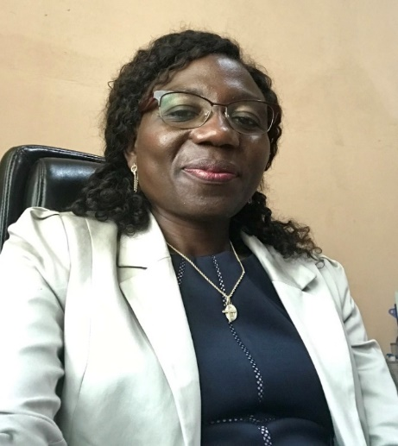**Prof. Anise N. Happi** holds a PhD in Veterinary clinical pathology (Molecular pathology), a Master’s degree in Veterinary Sciences and a DVM from the University of Ibadan, Nigeria. She held a postdoctoral research fellowship at Harvard University, USA, and several other fellowships in Molecular Biology and Genomics. She previously taught at the Department of Veterinary pathology, University of Ibadan, Nigeria. She currently serves as the Deputy Director of One health Research Zoonotic Diseases Surveillance at the Institute of Genomics and Global Health-IGH (formerly ACEGID) at Redeemer's University, Nigeria, where she leads significant research initiatives. She is also a Fellow of the College of Veterinary Surgeons of Nigeria, and a member of the Veterinary Council of Nigeria. Her research interests span zoonoses and emerging infectious diseases, particularly Lassa fever and other diseases of animal-origin, including the development of vaccines for Ebola and Lassa fever. Prof. Happi will talk on: Harnessing evolutionary genomics for comprehensive disease surveillance and pandemic preparedness through a One Health Approach.

Pandemics pose significant global health and economic threats, often emerging from zoonotic reservoirs where pathogens undergo genetic evolution that enhances their transmissibility and virulence. Evolutionary genomics, is now an important tool in understanding the adaptation and spread of pathogens before, during, and after they have caused pandemics. At the Centre for One Health Research and Zoonotic Diseases Surveillance, IGH, our work leverages the power of evolutionary genomics to detect pathogens, track pathogen evolution, guide surveillance strategies, improve diagnostics, and inform policy-making, for improved preparedness to handle pandemics. We use the One Health approach, which integrates human, animal, and environmental health systems. We have sequenced the Lassa fever virus (LASV), SARS-CoV-2, Crimean-Congo Hemorrhagic Fever (CCHF) virus, Lumpy Skin Disease Virus (LSDV) strain and African Swine Fever (ASF) virus, as well as the COVID-19 pandemic strains and gained insights, patterns and interactions useful for surveillance. These findings have supported the development of rapid diagnostic tests. The results and patterns will be discussed, within the perspectives of surveillance, diagnostics and overall preparedness for managing disease outbreaks on the continent.

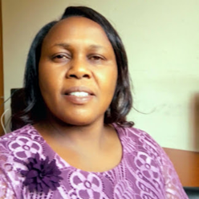 **Dr. Rispah Torrorey-Sawe** is a Senior Lecturer in the Department of Pathology, Immunology Section, at the School of Medicine, College of Health Sciences, Moi University, Kenya. She holds a PhD in Immunology, with her research focusing on the characterization of breast cancer molecular subtypes in relation to tumor-infiltrating leukocytes. Her work bridges immunogenomics and clinical application, advancing innovative approaches to disease diagnosis, surveillance, and management, particularly tailored to African populations.

Dr. Torrorey-Sawe specializes in breast cancer genomics, employing Next-Generation Sequencing (NGS) and pharmacogenetics to inform personalized treatment strategies and address challenges such as drug resistance and recurrence. She is also a passionate advocate for the ethical conduct of genomics research, contributing a chapter to Global Bioethics: Addressing Current Challenges, Innovations, and the Needs of Underserved Populations, with a focus on equitable access to genomic advancements. Since 2021, she has led bioinformatics training initiatives at Moi University in collaboration with H3Africa and is currently partnering with Linköping University (Sweden) to strengthen regional capacity in bioinformatics and phylogenetics, including companies like BioReperia and GKNOWMIX —that integrate NGS technologies into cancer treatment, and advance Pathology-Supported Genetic Testing and precision intervention.

Her presentation will explore how genomic technologies are transforming disease diagnostics, surveillance, and management in Africa. Focusing on both infectious and non-communicable diseases, she will highlight the role of personalized genomic medicine, including Next-Generation Sequencing (NGS), pharmacogenetics, and zebrafish patient-derived xenograft models, in improving outcomes of patients on treatment. Drawing on her work in cancer genomics, she will demonstrate how genomic testing guides tailored treatments, enhances prognostic accuracy, and predicts drug responses. Additionally, she will address the ethical considerations in genomic research, advocating for equitable access and responsible implementation. Finally, she will showcase ongoing efforts in bioinformatics training and capacity building across Africa, aiming to establish a sustainable infrastructure for integrating genomic tools into routine clinical practice. By combining scientific innovation with ethical responsibility and capacity development, this presentation will offer a vision for how genomics can be harnessed to meet Africa’s unique health challenges.